Shadi Jiha #40131284

**Technical**: done by professional. **Academic**: done by scholar

Definition:

**Sentence**: Aluminum is a lightweight metal that is often used for high-tension power transmission.

**Extended**: An extended definition usually begins with a sentence definition but then provides more specific detail about a word

**Parenthetical**: Parenthetical definitions consist of words that quickly explain a term and are included in the same sentence as the word being defined

**Gloss**: Contains words like “known as, defined as, called” or devices such as “e.g. or i.e.” It is usually embedded within a sentence.

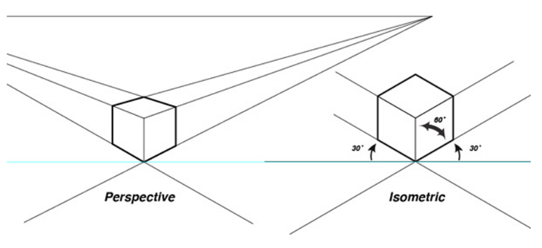

**Visual Specification of Tolerances**

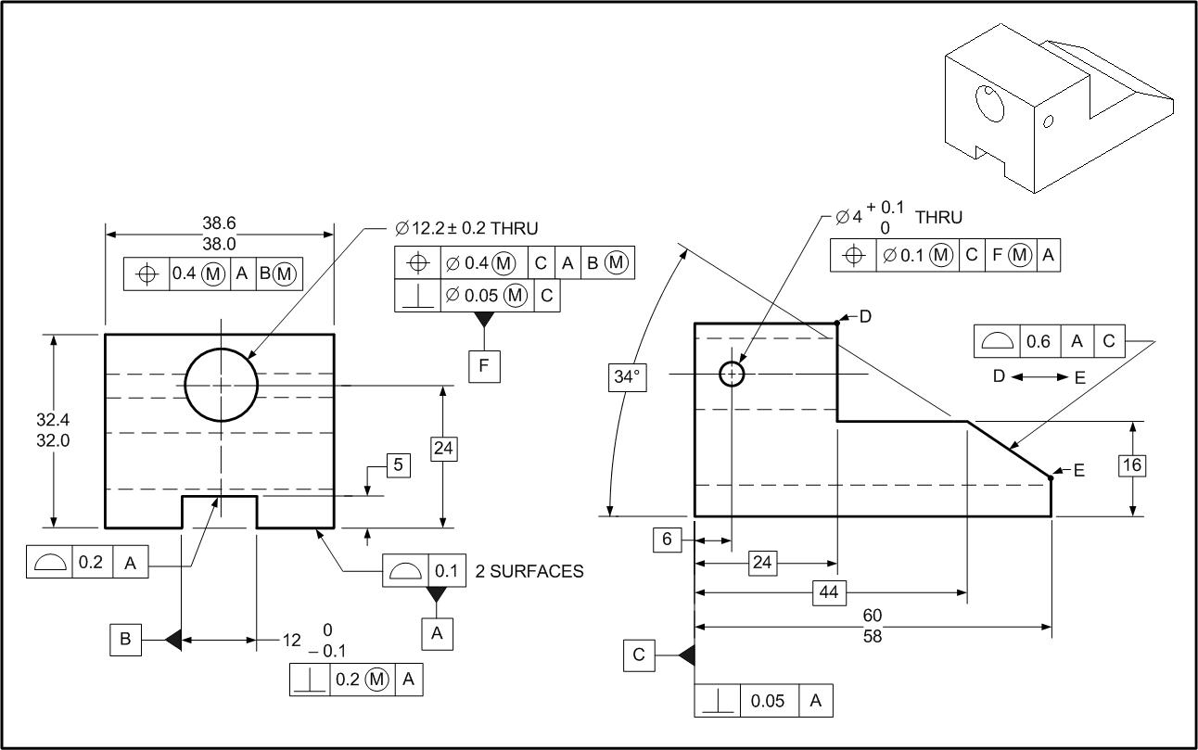

**Conceptual diagrams:** Conceptual diagrams: context and synthesis context and synthesis

**Maps**: geographic context and information rich geographic context and information rich

**Photos**: Photos: describe methods, study site description, describe methods, study site description, processes & relevance processes & relevance

**Video clips or Animations:** Video clips: capture system dynamics capture system dynamics

**Tables & figures:** scientific data scientific data

**Diagrams and Schematics:** parametric drawings of various views of an object or conceptual representations of an operation or layout

**Dimensioning**

Accuracy: correct values must be given.

* Clearness: dimensions must be placed in appropriate positions.
* Completeness: nothing must be left out, and nothing duplicated.
* Readability: the appropriate line quality must be used for legibility.

**Cross-Sectional drawing:**

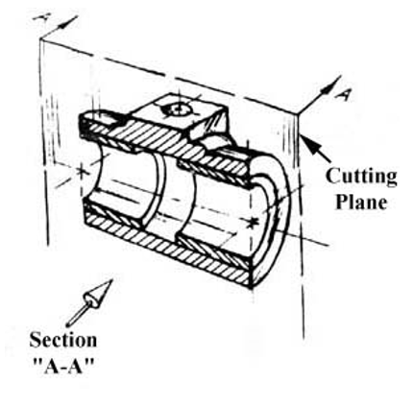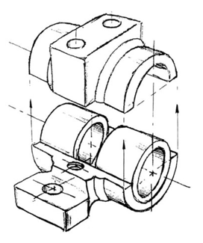

**Assembly drawing:**



**Example/Analogy:** A definition by example demonstrates how the term to be defined is similar to or shares features with another term that may be more familiar to the intended audience.

**Aristotelian:** Term + general class + distinguishing feature(s)

Term + Species + differentia(e)

e.g.: A solar cell is a device that converts the energy of sunlight into electrical energy.

**Etymological:** The term definition comes from the Latin word *definio* which means “to limit or bound”; thus, a definition sets the boundaries of a word’s meaning.

**Thematic Elements of Definitions**

* Etymological Definition
* Aristotelian Definition
* Example/Analogy Definition
* Comparison/Contrast

**Extended definition:**

* function of the term defined
* location or context of the term defined
* physical traits of the term defined
* causes and/or effects of the term defined

**Contrast/Comparison/Distinction:** Contrastive definitions define at least two terms at the same time by setting up a comparison between them. They usual present an account of how a concept has changed over time, or they provide an overview of how experts today view the term differently than those in the past.

e.g. The former deals with…, while the latter…

**How to improve efficiency:**

More (or less) info than the readers need

Irrelevant or un-interpreted info

Confusing organization

Jargon or vague tech expressions readers cannot understand

More words than readers need

Uninviting appearance or confusing layout

No visual aids when readers expect them

Jargon is efficient, and exclusive

**Audience analysis:** is a process used to identity and understand the priorities and influences for a group of people for which a document to be produced.

Target audience: is those people whose behavior must change …

**Socio-demographic characteristics**: ex. Sex, age, language, religion

**Geographic characteristics**: like where the audience lives and how that might impact behavior.

**Psychographic characteristics**: such as needs, hopes, concerns and aspirations

**Background knowledge**: of the audience members and their current actions related to a particular issue.

**Barriers and facilitators**: that prevent or encourage audience members to adopt the desired behavior change.

**Gender**: and how it impacts audience members’ behavior and ability to change

**Effective communication channels**: for reaching the audience.

**Decision making unit (DMU)**: is a term that describes a group of individuals that are involved in deciding the course of action for within a specific audience.

(Least influence) (Most influence)

Users < initiators < influencers < buyers < gatekeepers < decision makers